Stolen from: 2006 WPI High School Programming Contest
You are given a two-dimensional rectangular board consisting of columns (labeled 1, 2, … N) and rows (labeled A, B, C and so on) that contain an arrangement of three types of board pieces. You can assume the number of rows and columns are both less than or equal to 20.
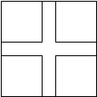 |  | 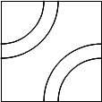 |  | 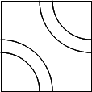
1 |  | 2 |  | 3
Crossing |  | West/North Curves |  | West/South Curves
A board consists of an arrangement of these pieces (there are no gaps). For example, the following is a valid board arrangement. Note that the columns are labeled left to right while the rows are labeled from top to bottom. Each square has a label, thus the upper left square in the board is “A1”.
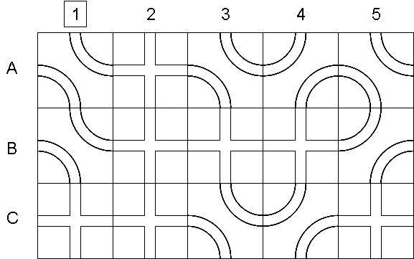
A train will enter the board at square A1 from the top and proceed through the board following the track as determine by the individual pieces until the train exits the board. Your task is to return an ArrayList<String> containing the sequence of squares in the order that the train encounters them. In the above board configuration, the train traverses the following path: A1 A2 A3 B3 C3 C4 B4 A4 A5 B5 B4 B3 B2 B1 A1. Therefore the getRoute() method returns an ArrayList containing the following Strings (in this order):
“A1” “A2” “A3” “B3” “C3” “C4” “B4” “A4” “A5” “B5” “B4” “B3” “B2” “B1” “A1”

You have been given the incomplete TrainTracks class. You should add your own instance variables, implement the constructor and implement thegetRoute() method. You may add any private helper methods you require.

public class TrainTracks {
// add your own instance variable

public TrainTracks(int [][] g)
{
// implement the contructor
}

public ArrayList<String> getRoute()
{
// add your own implementation
return new ArrayList<String>();
}
}

Sample code execution

int[][] tracks= {{3, 1, 3, 2, 3}, {3, 1, 1, 1, 2}, {1, 1, 3, 2, 1}};
TrainTracks thomas = new TrainTracks( tracks );
ArrayList<String> sol = thomas.getRoute();

Sol will contain the following Strings (in this order)
"A1" "A2" "A3" "B3" "C3" "C4" "B4" "A4" "A5" "B5" "B4" "B3" "B2" "B1" "A1"

